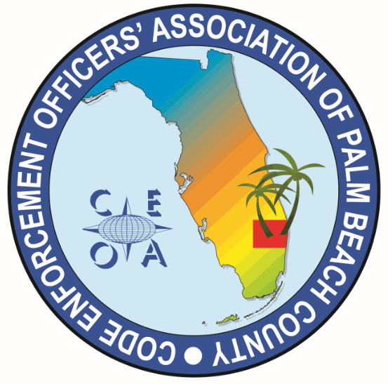

CODE ENFORCEMENT OFFICERS ASSOCIATION OF PALM BEACH COUNTY
BOARD MEETING AGENDA
NOVEMBER 14, 2025
10:00 AM
ZOOM

CALL MEETING TO ORDER, ROLL CALL, ESTABLISH A QOURUM, RULES OF MEETING

APPROVAL OF THE NOVEMBER 12, 2025 MEETING MINUTES – DWAYNE JOHNSON

TRASURER REPORT – NONE

OLD BUSINESS

- CONTINUE DISCUSION FROM NOVEMBER 12TH BOARD MEETING ON HOLIDAY LUNCH DURING THE TRAINING BLOCK CITY OF DELRAY BEACH PUBLIC LIBRARY 8:15 AM TO 3:00 PM DECEMBER 4, 2025

- FOOD OPTIONS (WHO WILL ORDER AND PICK UP FOOD? TWO VOULUNTEERS)
- DRINK OPTIONS, ICE, AND COOLERS (WHO WILL PICK UP DRINKS AND BRING COOLERS? TWO VOLUNTEERS)
- TABLECLOTHS, PLATES, NAPKINS CUTLERY AND DECORATIONS (WHO WILL PURCHASE? TWO VOLUNTEERS
- SET UP AND CLEAN UP ROOM (ALL BOARD MEMBERS ARRIVE AT 8:15)
- CONSIDERATION OF PBC FOOD BANK DRIVE CASH DONATIONS OR FOOD DRIVE? WHO WILL DELIVER DONATION TO FOOD BANK?
- PUSH 50/50 RAFFLE AT SIGN IN TABLE

NEW BUSINESS
NONE

- ITEMS TO BE CONSIDERED FOR NEXT MEETING AGENDA

- SET NEXT MEETING DATE AND TIME *Elections and Annual meeting in March 2026

ADJOURNMENT

